**DEPARTMENT OF CLINICAL PATHOMORPHOLOGY CM UMK**

**HEAD OF THE DEPARTMENT:**

**Prof. Dariusz Grzanka, MD, PhD*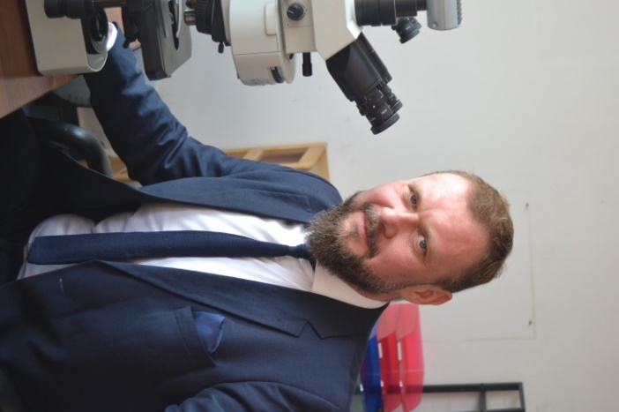***

**PERSONEL OF THE TEACHING TEAM:**

Prof. Dariusz Grzanka, MD, PhD

Natalia Skoczylas-Makowska, MD, PhD

Jakub Jóźwicki, MD, PhD

Paulina Antosik, PhD

Anna Klimaszewska-Wiśniewska, PhD

Martyna Parol-Kulczyk, PhD

Izabela Neska-Długosz, MD

Magda Zwolińska, MD

Radosław Wujec, MD

Kacper Naglik, MD

Damian Łukasik, MD

Anna Tomczak, MD

**TEACHER’S OPENING DAYS AND HOURS:**

Prof. Dariusz Grzanka, MD, PhD Wednesday 14:00 – 16:00

Natalia Skoczylas-Makowska, MD, PhD –Monday 7:30 – 8:00, Wednesday 12:30 – 13:00, Thursday 13:00 – 14:00

Jakub Jóźwicki, Md, PhD – Tuesday 10:00 – 12:00

Paulina Antosik, MD, PhD – Wednesday 10:00 – 12:00

Anna Klimaszewska-Wiśniewska, PhD – Thursday 10:00 – 12:00

Izabela Neska-Długosz, MD – Thursday 12:00 – 14:00

Magda Zwolińska, MD – Thursday 10:00 – 12:00

Radosław Wujec, MD – Tuesday 10:00 – 12:00

Kacper Naglik, MD – Wednesday 12:00 – 14:00

Damian Łukasik, MD – Monday 10:00 – 12:00

Martyna Parol-Kulczyk, PhD – Friday 12:00 – 14:00